**cleaned_insurance_Data datasets**

Removing **Applicant_ID**

After Removing **Applicant_ID**

Sorting **Years_of_Insurance** from Smallest to Largest

After Sorting **Years_of_Insurance** from Smallest to Largest

Setting Blank value to NULL in **Year_last_admitted**

After Setting Blank value to NULL in **Year_last_admitted**

**Cleansed_Health Insurance Coverage file**

Setting blank to NULL in **State Medicaid Expansion (2016)**



After Setting blank to NULL in **State Medicaid Expansion (2016)**



Setting value from Blank to 0 in **Medicaid Enrollment (2013)**



After Setting value from Blank to 0 in **Medicaid Enrollment (2013)**



Setting value from Blank to 0 in **Medicaid Enrollment Change (2013-2016)**



After Setting value from Blank to 0 in **Medicaid Enrollment Change (2013-2016)**



**Cleansed_Health Insurance data Policy and claims data_Health Insurance claims data excel file**

Sorting Type by **Alphabetic Order**

After Sorting Type by **Alphabetic Order**

Setting DOB values to NULL in **DOB**

After Setting DOB values to NULL in **DOB**

Setting district values to NULL in **district**

After setting district values to NULL in **district**

Setting states values to NULL in **states**

After setting states values to NULL in **states**

Setting blank values to 0 in **claim_amt2**

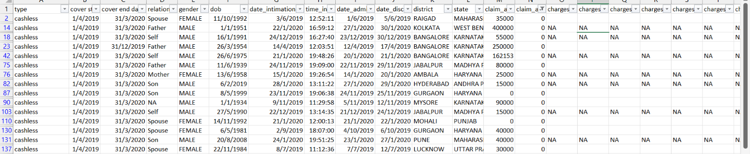After Setting blank values to 0 in **claim_amt2**

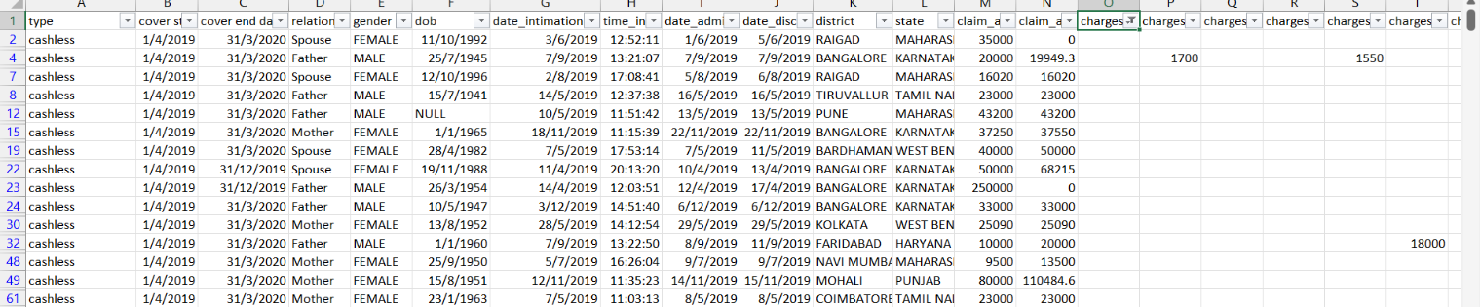Setting blank values to 0 in **charges_accommodation**

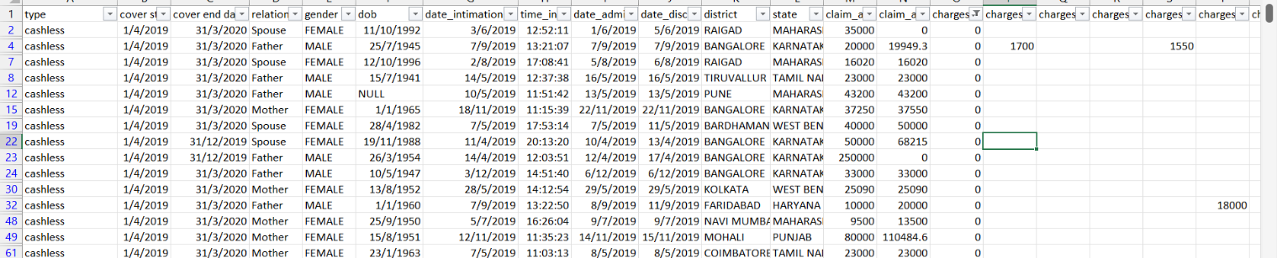After Setting blank values to 0 in **charges_accommodation**

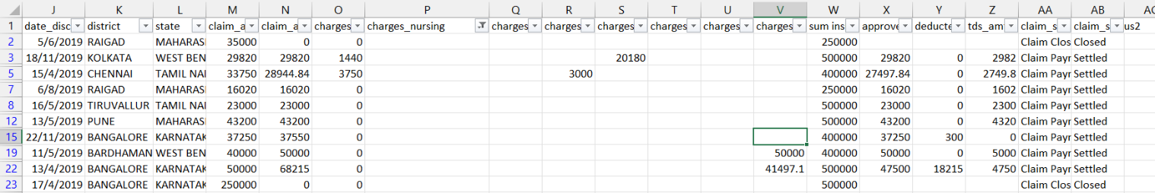Setting blank values to 0 in **charges_nursing**

After Setting blank values to 0 in **charges_nursing**

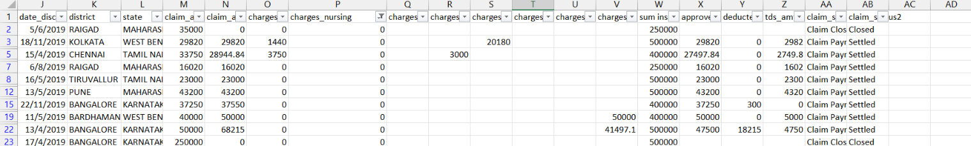

Setting blank values to 0 in **charges_package**

After Setting blank values to 0 in **charges_package**

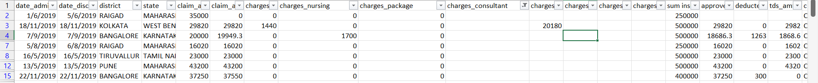Setting blank values to 0 in **charges_consultant**

After Setting blank values to 0 in **charges_consultant**

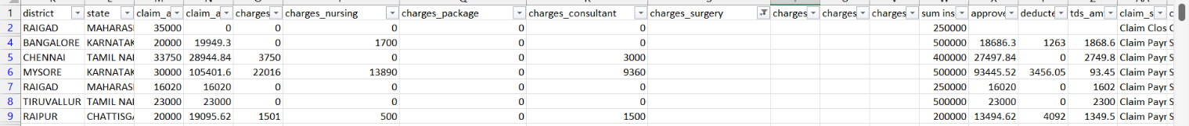Setting blank values to 0 in **charges_surgery**

After Setting blank values to 0 in **charges_surgery**

Setting blank values to 0 in **charges_pharmacy**

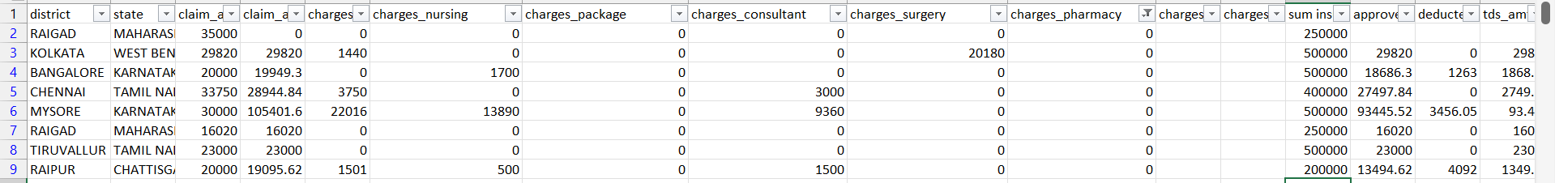After Setting blank values to 0 in **charges_pharmacy**

Setting blank values to 0 in **charges_ambulance**



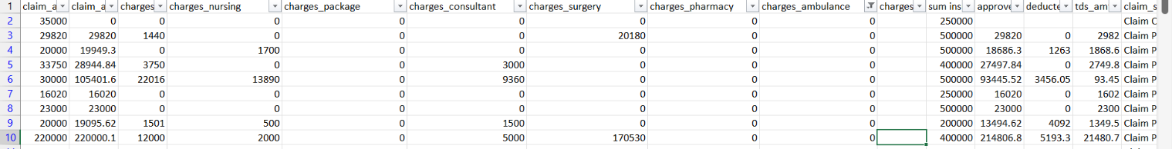After Setting blank values to 0 in **charges_ambulance**

Setting blank values to 0 in **charges_maternity**

After Setting blank values to 0 in **charges_maternity**

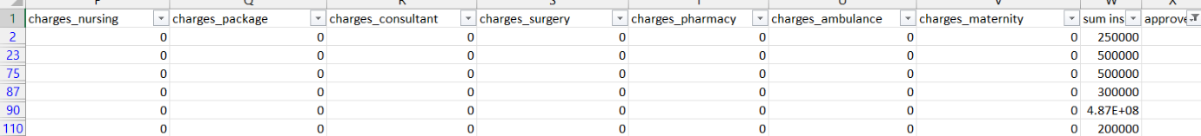Setting blank values to 0 in **approved_amt**

After Setting blank values to 0 in **approved_amt**

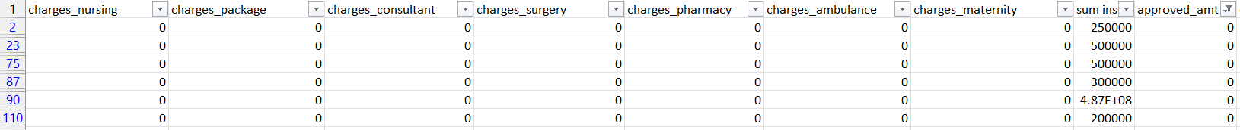

Setting blank values to 0 in **deducted_amt**

After Setting blank values to 0 in **deducted_amt**

**Cleansed_inpatientCharges excel file**

Removing unwanted column in **Cleansed_inpatientCharges**

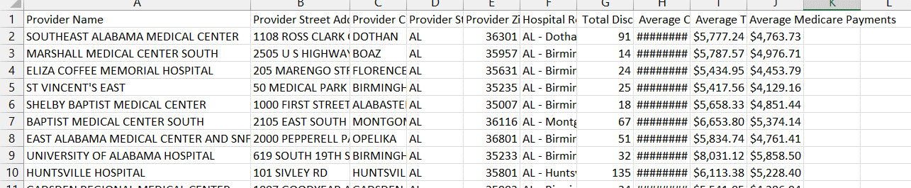After Removing unwanted column in **Cleansed_inpatientCharges**

Changing Age from Measures to Dimensions

Filter out unknown from Smoking Status

Changing Heart Decs History from Measures to Dimensions

Changing Weight from Measures to Dimensions

Changing Age from Measures to Dimensions

Changing Children from Measures to Dimensions

Changing Bmi from Measures to Dimensions

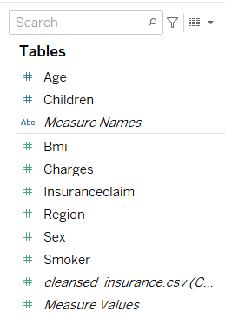

Changing Sex from Measures to Dimensions

